1.

**Entities:**

Driver(**Employee number**, name, adress, phone number)

Bus(**Registration number**, number of passengers, decks)

Route(**Route number**, average passengers a day)

Town(name)

Garage()

Stage()

2.

**Relationships:**

Drivers allocated to a Stage many to one

Buses drive a Route many to one

Route has Stages one to many

Town has a Garage one to one optional

Stages go through towns many to many

Garage has buses one to many

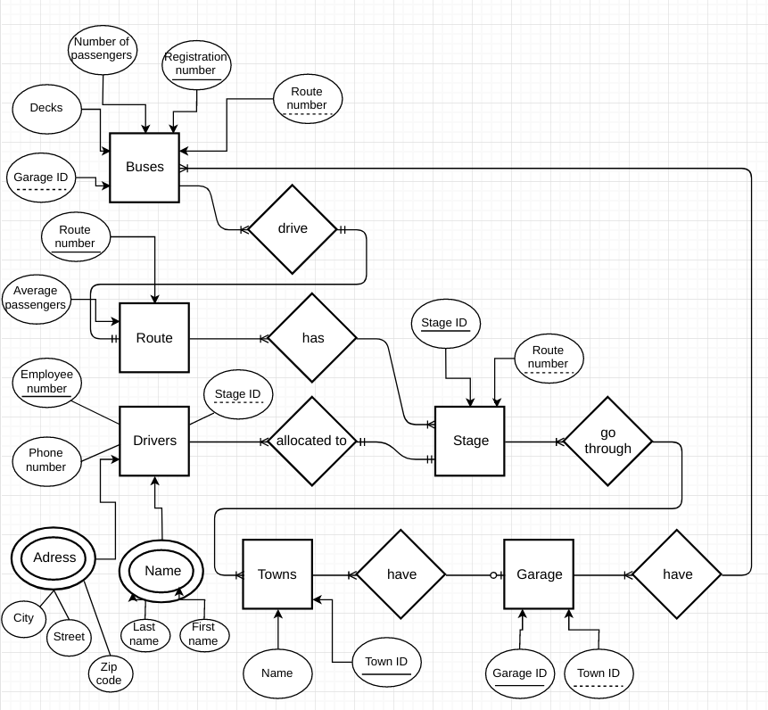3/4.

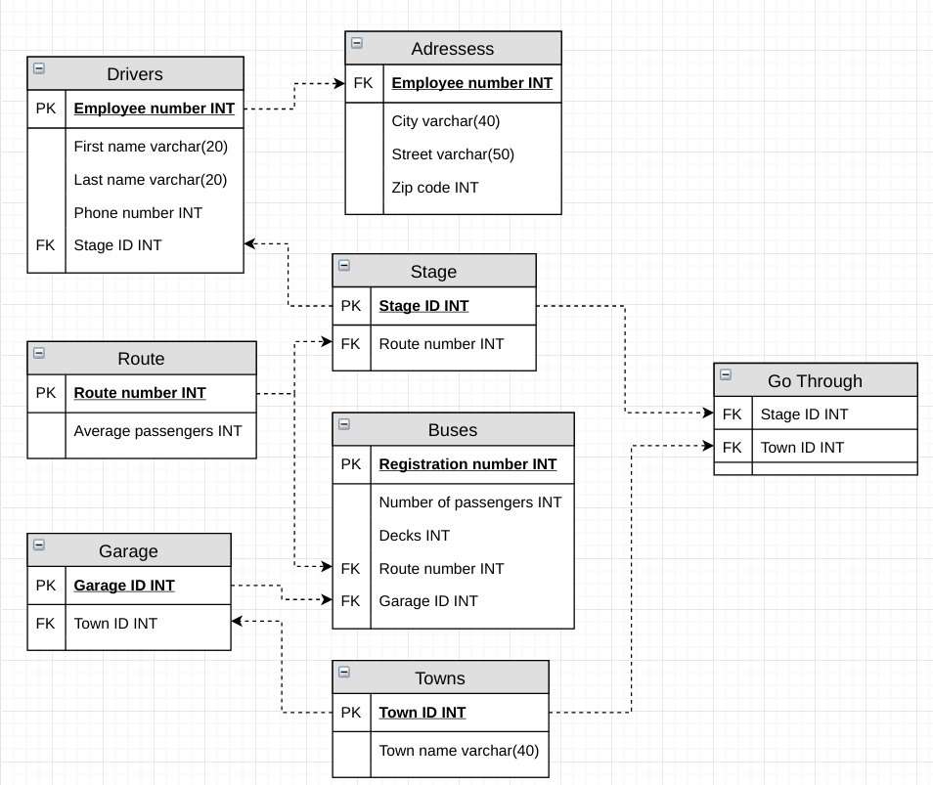5/6.

7.

DROP DATABASE IF EXISTS 2109013290_bus_db;

CREATE DATABASE 2109013290_bus_db;

USE 2109013290_bus_db;

#Route

CREATE TABLE route (

route_number INT PRIMARY KEY NOT NULL,

average_passengers INT

);

#Stage

CREATE TABLE stage(

stage_ID INT PRIMARY KEY NOT NULL,

route_number INT NOT NULL,

#Aðkomulyklar

CONSTRAINT route_number_FK FOREIGN KEY (route_number) REFERENCES route(route_number)

);

#Towns

CREATE TABLE towns(

town_ID INT PRIMARY KEY NOT NULL,

town_name VARCHAR(40) NOT NULL

);

#Go Through

CREATE TABLE go_through (

stage_ID INT NOT NULL,

town_ID INT NOT NULL,

#Aðkomulyklar

CONSTRAINT stage_ID_FK FOREIGN KEY (stage_ID) REFERENCES stage (stage_ID),

CONSTRAINT town_ID_FK FOREIGN KEY (town_ID) REFERENCES towns (town_ID)

);

#Garage

CREATE TABLE garage(

garage_ID INT PRIMARY KEY NOT NULL,

town_ID INT NOT NULL,

#Aðkomulyklar

CONSTRAINT town_ID_FK2 FOREIGN KEY (town_ID) REFERENCES towns(town_ID)

);

#Buses

CREATE TABLE buses(

registration_number INT PRIMARY KEY NOT NULL,

number_of_passengers INT,

decks INT(1),

route_number INT NOT NULL,

garage_ID INT NOT NULL,

#Aðkomulyklar

CONSTRAINT route_number_FK2 FOREIGN KEY (route_number) REFERENCES route(route_number),

CONSTRAINT garage_ID_FK FOREIGN KEY (garage_ID) REFERENCES garage(garage_ID)

);

#Drivers

CREATE TABLE drivers(

employee_number INT PRIMARY KEY NOT NULL,

first_name VARCHAR(20) NOT NULL,

last_name VARCHAR(20) NOT NULL,

phone_number INT,

stage_ID INT NOT NULL,

#Aðkomulyklar

CONSTRAINT stage_ID_FK2 FOREIGN KEY (stage_ID) REFERENCES stage(stage_ID)

);

#Adressess

CREATE TABLE adressess(

employee_number INT NOT NULL,

city VARCHAR(40) NOT NULL,

street VARCHAR(50) NOT NULL,

zipcode INT NOT NULL,

#Aðkomulyklar

CONSTRAINT employee_number_FK FOREIGN KEY (employee_number) REFERENCES drivers(employee_number)

);